**1.1 Project Overview**

1.INTRODUCTION

SB Flights is a next-generation digital platform designed to transform the way you book and manage flight tickets. Whether you’re a frequent flyer or an occasional traveler, SB Flights brings simplicity, speed, and convenience to your travel planning.

Our intuitive web application makes it easy to find and book the perfect flight. Simply enter your travel dates, destinations, number of passengers, and basic details — and receive instant ticket confirmation. No more long queues or confusing systems.

Imagine having comprehensive flight details right at your fingertips. From departure and arrival times to flight classes and available amenities, SB Flights provides all the essential information you need to make informed decisions. No more second-guessing or uncertainty—every aspect of your travel is made crystal clear, ensuring complete confidence in your booking.

The booking process itself is designed to be as simple and streamlined as possible. Just enter your name, age, preferred travel dates, departure and arrival cities, and the number of passengers. Once you submit your booking request, you’ll receive instant confirmation of your reservation. Say goodbye to long queues and complex reservation systems—SB Flights makes booking your next journey quick, easy, and hassle-free

.

Upon successful booking, you’ll gain access to our dedicated Booking Details page, which becomes your personal travel companion. This page offers a comprehensive overview of all your current and previous bookings, enabling you to effortlessly manage your travel plans and stay organized. With SB Flights, your essential travel information is always just a click away, supporting a stress-free and well-managed journey.

But SB Flights isn’t just built for travelers—it also includes powerful tools for flight service administrators. Our intuitive Admin Dashboard allows administrators to efficiently manage ticket reservations. They can easily view a list of all available flights open for booking, monitor ongoing and past reservations, and maintain complete control over the booking process. Each flight service has its own separate login and registration pages, ensuring privacy and security for both administrators and users.SB Flights is here to enhance your travel experience by providing a seamless and convenient way to book flight tickets. With our user-friendly interface, efficient booking management, and robust administrative features, we ensure a hassle-free and enjoyable flight ticket booking experience for both users and flight administrators alike.

Get ready to embark on a new era of flight travel with SB Flights – your ticket to effortless booking and unforgettable journeys.

**1.2 Purpose**

* **Solve complex problems in a way that fits the state of your customers:**  
  Our customers (budget travelers, busy professionals) want quick, transparent, and reliable ways to find flights. Our platform is tailored to their needs—saving them time and reducing stress.
* **Succeed faster and increase solution adoption:**  
  By aggregating multiple airlines, predicting price changes, and offering smart notifications, we align with customers’ existing behaviors (using mobile apps, price comparison tools) but deliver it faster and smarter.
* **Sharpen communication and marketing strategy:**  
  We focus our messaging on “Save time. Save money. Travel smart.”—directly tapping into customers’ triggers of convenience and cost savings.
* **Increase touch-points and build trust:**  
  Frequent, helpful notifications on price drops or better routes build trust and keep users engaged, addressing urgent or costly issues like last-minute fare hikes.
* **Understand and improve the existing situation:**  
  By studying how travellers currently use multiple platforms and still feel uncertain, we streamline the process into one intuitive tool, reducing confusion and decision fatigue.

2.1 Problem Statement

**2. IDEATION PHASE**

With the growth of air travel, passengers are overwhelmed by scattered flight information across different airline websites and travel aggregators. They often spend significant time comparing flights, worrying about hidden fees, and facing uncertainties around cancellations and refunds.

“To build a secure, scalable Flight Finder platform that enables users to search, filter, and book flights seamlessly, while offering administrators the tools to manage flight schedules and bookings effectively.”

Who are we empathizing with?

* Primary: Air travelers looking to find and book flights easily.
* Secondary: Admins managing flight schedules and bookings.

💭 What do they THINK & FEEL?

* Worry about getting the best price and avoiding hidden fees.
* Nervous about cancellations, refunds, or schedule changes.
* Appreciate transparency, trustworthiness, and quick results.
* Value the ease of comparing flights on one platform.

**Key Challenges**

* Fragmented information across multiple booking platforms.
* Hidden costs revealed late in the booking process.
* Lack of integrated management of bookings and cancellations.
* Security concerns while making online payments.

**Opportunity**

By building a **Flight Finder application**, we can:

* Aggregate flights from multiple airlines with clear filters (price, duration, stops, airlines).
* Offer transparent pricing without hidden surprises.
* Integrate secure payment systems and trackable bookings.
* Provide real-time updates and easy cancellations.

**2.2 Empathy Map Canvas**

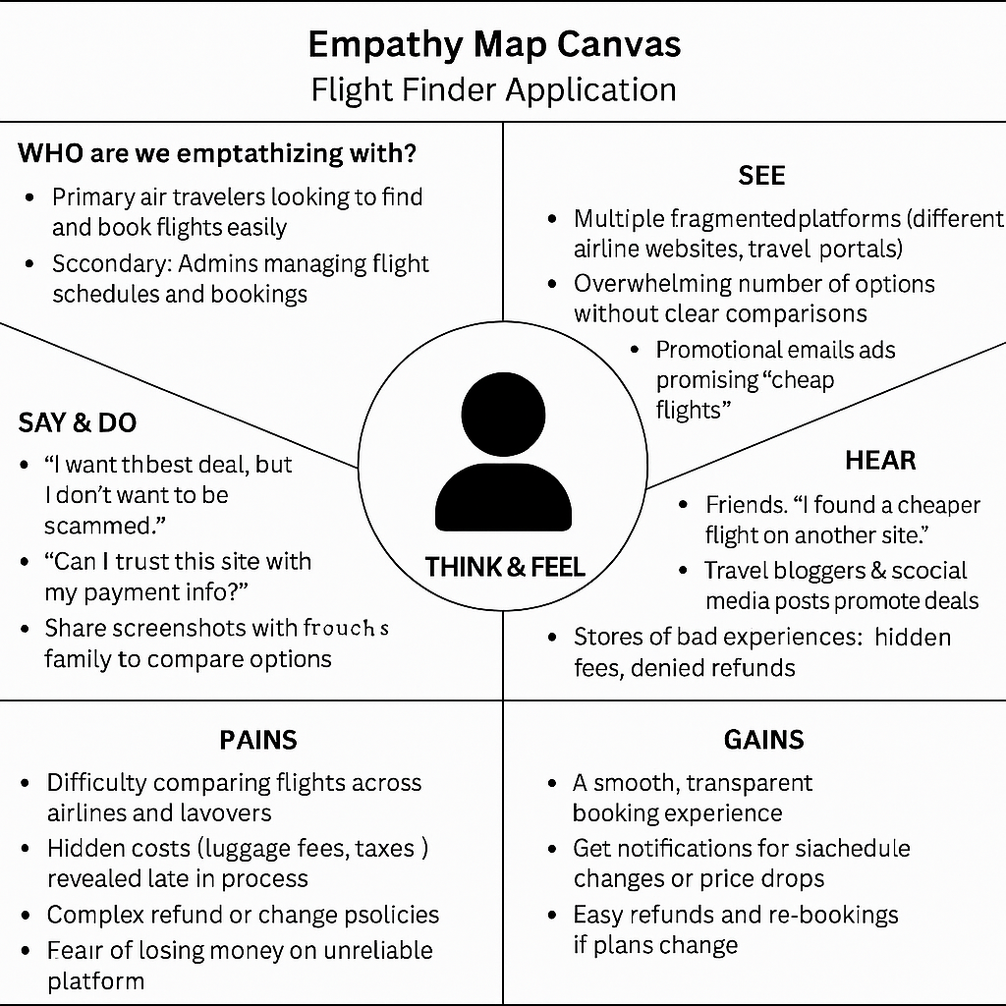



Brainstorming provides a free and open environment that encourages everyone within a team to participate in the creative thinking process that leads to problem solving. Prioritizing volume over value, out-of-the-box ideas are welcome and built upon, and all participants are encouraged to collaborate, helping each other develop a rich amount of creative solutions.

Use this template in your own brainstorming sessions so your team can unleash their imagination and start shaping concepts even if you're not sitting in the same room.

Reference: <https://www.mural.co/templates/brainstorm-and-idea-prioritization>

**2.3 Brainstorming**

**Step-1: Team Gathering, Collaboration and Select the Problem Statement**

**Step-2: Brainstorm, Idea Listing and Grouping**

**Step-3: Idea Prioritization**

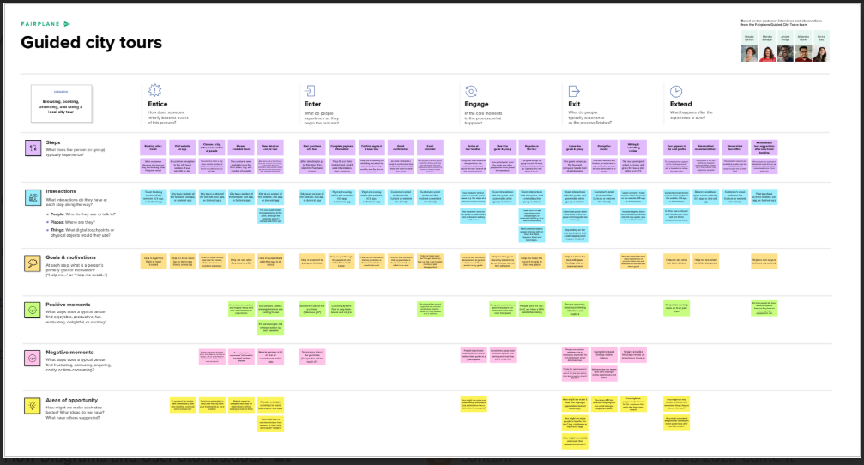

**3.1 Customer Journey map**

**3. REQUIREMENT ANALYSIS**

**Functional Requirements:**

Following are the functional requirements of the proposed solution.

|  |  |  |
| --- | --- | --- |
| **FR No.** | **Functional Requirement (Epic)** | **Sub Requirement (Story / Sub-Task)** |
| FR-1 | User Registration and Login | Registration through Form or Login through Form |
| FR-2 | Flight Search & Booking | -Search flights by route, date, - View flight details  - Book tickets for selected flights |
| FR-3 | Admin Flight Management | -Add, update, or delete flights  - Monitor user bookings  - Generate reports |
| FR-4 | Booking History & Details | -View current and past bookings |

**Non-functional Requirements:**

Following are the non-functional requirements of the proposed solution.

|  |  |  |
| --- | --- | --- |
| **FR No.** | **Non-Functional Requirement** | **Description** |
| NFR-1 | **Usability** | Interface should be intuitive, responsive, and accessible on web and mobile. |
| NFR-2 | **Security** | Implement secure login, role-based access, data encryption, and HTTPS protocol. |
| NFR-3 | **Reliability** | Ensure consistent system uptime, backup mechanisms, and failover strategies. |
| NFR-4 | **Performance** | Handle multiple simultaneous bookings efficiently; average response < 2 sec. |
| NFR-5 | **Availability** | System should be available 99.9% of the time, with minimal downtime. |
| NFR-6 | **Scalability** | The system must scale with increasing users, data, and flight partners. |

**3.2 Solution Requirement**

**User Stories**

Use the below template to list all the user stories for the product.

**3.3 Data Flow Diagram**

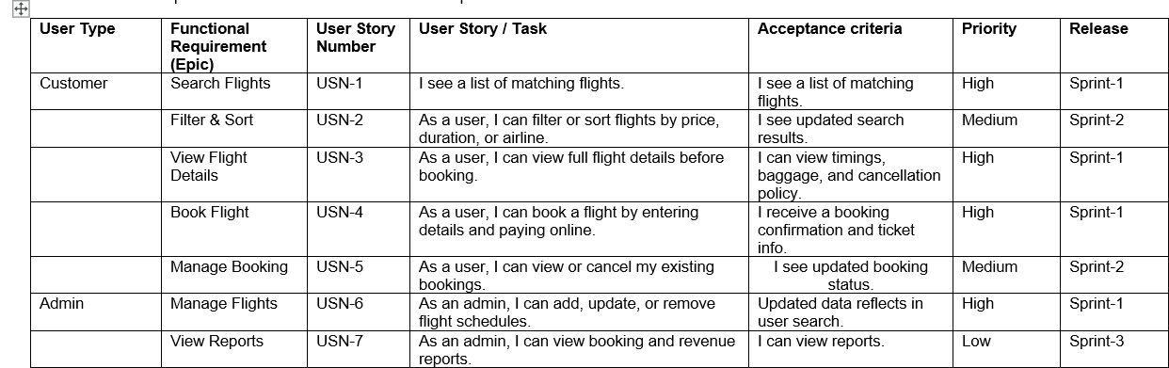

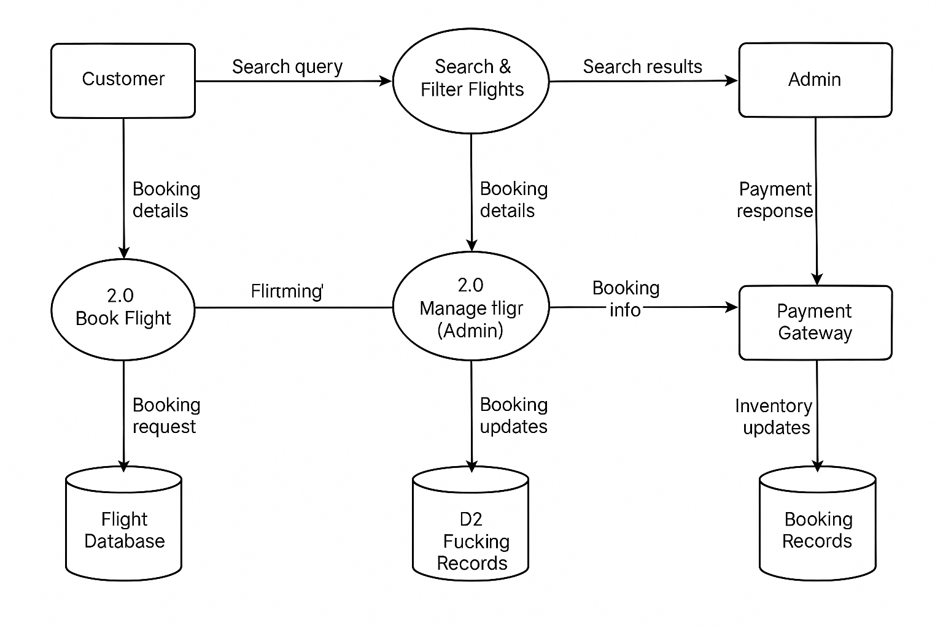

**Data Flow Diagrams:**

A Data Flow Diagram (DFD) is a traditional visual representation of the information flows within a system. A neat and clear DFD can depict the right amount of the system requirement graphically. It shows how data enters and leaves the system, what changes the information, and where data is stored.

**3.4 Technology Stack**

**Technical Architecture:**

The SB Flights is built using a scalable and modular 3-tier architecture, ensuring high performance, maintainability, and future scalability.

**Presentation Layer (Frontend):** Travelers can search for flights, view detailed flight information, and book tickets and administrators can log in to manage flight listings and monitor bookings and Built with modern web technologies (e.g., HTML5, CSS3, JavaScript frameworks like React).

**Business Logic Layer (Backend):**  Flight search, filtering, and booking management and user authentication and role-based access control (traveler vs. admin) and real-time seat availability and booking confirmation.

**Data Storage Layer**: Passenger profiles, booking history, and transaction records and Flight schedules, seat inventory, and airline information and Admin and service provider records.

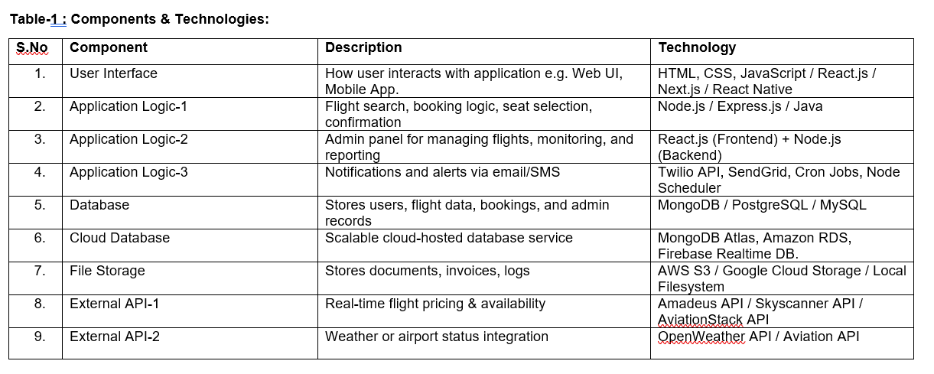

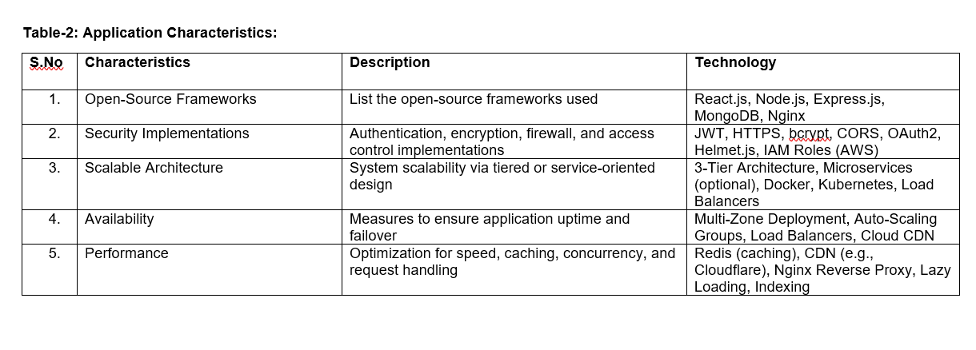

**Problem – Solution Fit Template:**

The Problem–Solution Fit represents the critical stage where we validate that a real customer problem exists, and that our solution effectively solves it. For our project “Flight Finder,” this means understanding travelers’ frustrations with booking flights and ensuring our platform directly addresses these pain points.

This concept is vital for entrepreneurs and innovators because it:

* Identifies clear behavioral patterns, needs, and annoyances of customers.
* Ensures we are not creating a solution looking for a problem, but rather solving an actual, validated issue.

**4.1 Problem Solution Fit**

**4. PROJECT DESIGN**

**Purpose:**

**Purpose in Our Project**

✅ **Solve complex problems in a way that fits the state of your customers:**  
Our customers (budget travelers, busy professionals) want quick, transparent, and reliable ways to find flights. Our platform is tailored to their needs—saving them time and reducing stress.

✅ **Succeed faster and increase solution adoption:**  
By aggregating multiple airlines, predicting price changes, and offering smart notifications, we align with customers’ existing behaviors (using mobile apps, price comparison tools) but deliver it faster and smarter.

✅ **Sharpen communication and marketing strategy:**  
We focus our messaging on **“Save time. Save money. Travel smart.”**—directly tapping into customers’ triggers of convenience and cost savings.

✅ **Increase touch-points and build trust:**  
Frequent, helpful notifications on price drops or better routes build trust and keep users engaged, addressing urgent or costly issues like last-minute fare hikes.

✅ **Understand and improve the existing situation:**  
By studying how travelers currently use multiple platforms and still feel uncertain, we streamline the process into one intuitive tool, reducing confusion and decision fatigue.

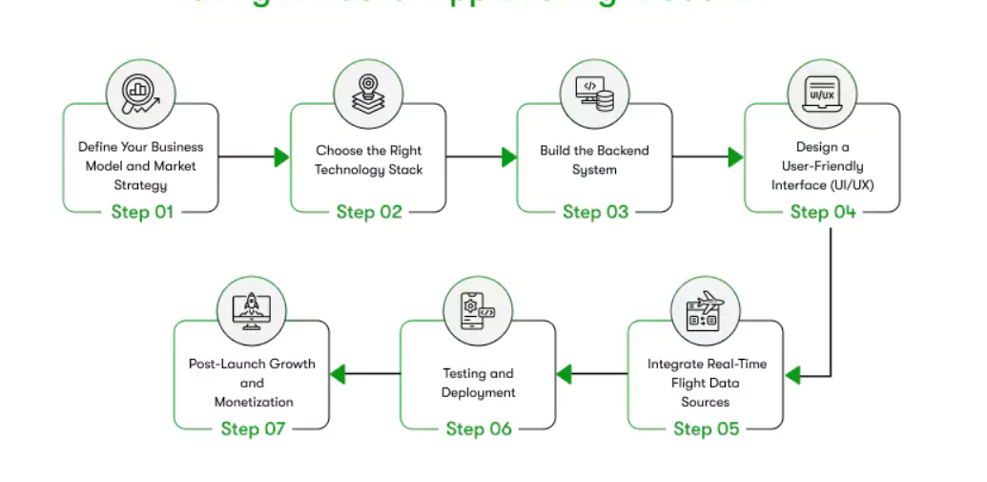

Project team shall fill the following information in the proposed solution template.

|  |  |  |
| --- | --- | --- |
| **S.No.** | **Parameter** | **Description** |
|  | Problem Statement (Problem to be solved) | Finding, comparing, and booking flights is often time-consuming, scattered across multiple platforms, and lacks a unified, user-friendly interface. Customers struggle to get the best options tailored to their needs quickly, while airlines and agencies need effective channels to reach potential travellers. |
|  | Idea / Solution description | Develop a Flight Finder application that allows users to search, filter, and book flights in an intuitive interface. The system connects to airline databases or APIs, providing real-time availability, booking options, secure payments, and automated notifications. Admins can manage flight inventories, monitor bookings, and generate reports. |
|  | Novelty / Uniqueness | Combines an easy search and booking process with intelligent filters (price, duration, stops, airlines) plus a built-in admin portal to manage flights. Includes secure online payments and real-time updates, reducing dependency on travel agents or fragmented platforms. |
|  | Social Impact / Customer Satisfaction | Simplifies air travel planning, saving customers time and effort while giving them more control over travel choices. Helps small airlines and agencies reach more customers, improving service accessibility. |
|  | Business Model (Revenue Model) | The platform can generate revenue through commissions on ticket bookings, premium placement for airlines, advertising, or offering a subscription model for frequent travelers to access exclusive deals and priority support. |
|  | Scalability of the Solution | The application is designed with modular, scalable architecture that can handle increasing numbers of users and integrate additional airlines, destinations, or even hotel bookings and packages in the future. It can be deployed on cloud infrastructure to handle dynamic load. |

4.2 Proposed Solution

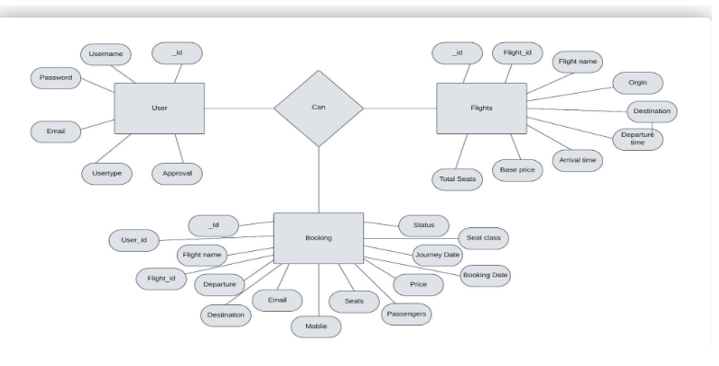

**Solution Architecture:**

Flight Finder system is to develop a user-friendly, secure, and scalable platform that allows customers to search, filter, and book flights easily. This system serves as a bridge between airline inventory systems and customers by providing a seamless experience for browsing available flights, making reservations, and managing bookings.

* Enables users to search for flights by specifying source, destination, travel dates, and other preferences.
* Allows filtering and sorting of search results based on price, duration, stops, and airlines.
* Facilitates quick booking by collecting passenger details and processing payments securely.
* Administrators can manage flight inventory, schedules, and monitor overall system usage.

**4.3 Solution Architecture**

*Figure 1: Architecture and data flow of the Flight Finder*

**5. PROJECT PLANNING & SCHEDULING**

**5.1 Project Planning**

**Product Backlog, Sprint Schedule, and Estimation (4 Marks)**

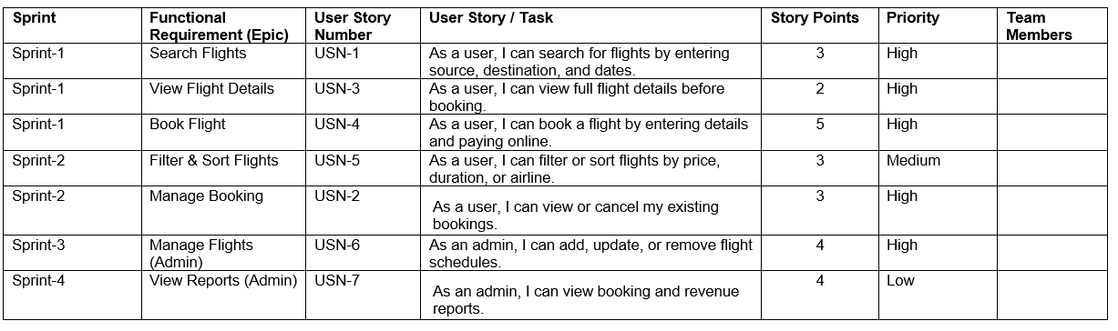

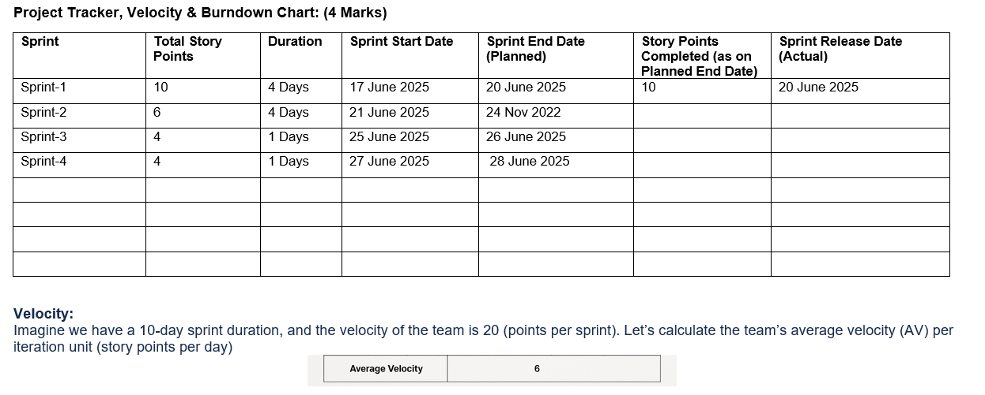

**6. FUNCTIONAL AND PERFORMANCE TESTING**

**Project Overview:**

Project Name: Flight Finder Application

Project Description: A web-based platform that allows customers to search, filter, and book flights, with secure payments and booking management. Admins can manage flight inventory and view reports.

Project Version: 1.0

Testing Period: 17 June 2025 to 27 June 2025

**Testing Scope:**

**Features & Functionalities to be Tested**

* Flight search based on source, destination, and dates
* Filtering & sorting flights (by price, duration, stops, airlines)
* Viewing detailed flight information
* Booking a flight with secure payment
* Managing user bookings (view/cancel)
* Admin dashboard for managing flight inventory
* Notifications & confirmation emails

**User Stories / Requirements to be Tested**

* USN-1: Search Flights
* USN-2: Filter & Sort Flights
* USN-3: View Flight Details
* USN-4: Book Flight & make payment
* USN-5: Manage Bookings
* USN-6: Admin manages flights
* USN-7: Admin views reports

**Testing Environment:**

URL/Location: https://localhost:5000

Credentials (if required):

|  |
| --- |
| **Admin: admin@gmail.com / admin123** |

|  |  |
| --- | --- |
|  | **User: john123@gmail.com / john123** |

**Test Cases:**

|  |  |  |  |  |  |
| --- | --- | --- | --- | --- | --- |
| **Test Case ID** | **Test Scenario** | **Test Steps** | **Expected Result** | **Actual Result** | **Pass/Fail** |
| TC-001 | Search for available flights | 1. Open app 2. Enter source, destination, date 3. Click search | List of matching flights is displayed | [Result] | Pass |
| TC-002 | Filter flights by price | 1. Perform a search 2. Apply price filter | Flights displayed according to selected price range | [Result] | Pass |
| TC-003 | View flight details | |  | | --- | | 1. Click on a flight |  |  | | --- | |  | | Detailed info (timing, stops, baggage, rules) shown | [Result] | Pass |
| TC-004 | Book a flight | 1. Select flight 2. Enter passenger details 3. Pay | Booking confirmed, ticket issued, email sent | [Result] | Pass |
| TC-005 | |  | | --- | |  |  |  | | --- | | Cancel booking | | 1. Go to 'My Bookings' 2. Cancel booking | Booking status updated, refund initiated | [Result] | Pass |
| TC-006 | Admin add flight schedule | 1. Login as admin 2. Add new flight schedule | Flight available in user search | [Result] | Pass |

**Bug Tracking:**

|  |  |  |  |  |  |
| --- | --- | --- | --- | --- | --- |
| **Bug ID** | **Bug Description** | **Steps to reproduce** | **Severity** | **Status** | **Additional feedback** |
| BG-001 | Booking fails on invalid card input | 1. Select flight 2. Enter wrong card data 3. Pay | Medium | Open | Should show clear error message |
| BG-002 | Search returns empty on valid inputs | 1. Enter valid locations 2. Click search | High | In Progress | Needs urgent fix |
| BG-003 | Admin report date filter not working | 1. Login admin 2. Apply date filter | Low | Open | Filter gives same results |

**Sign-off:**

Tester Name: Gayathri

Date:25 June 2025

Signature:Gayathri

**Notes:**

* Ensure that all test cases cover both positive and negative scenarios.
* Encourage testers to provide detailed feedback, including any suggestions for improvement.
* Bug tracking should include details such as severity, status, and steps to reproduce.
* Obtain sign-off from both the project manager and product owner before proceeding with deployment.

**7. RESULTS**

**Authentication:**

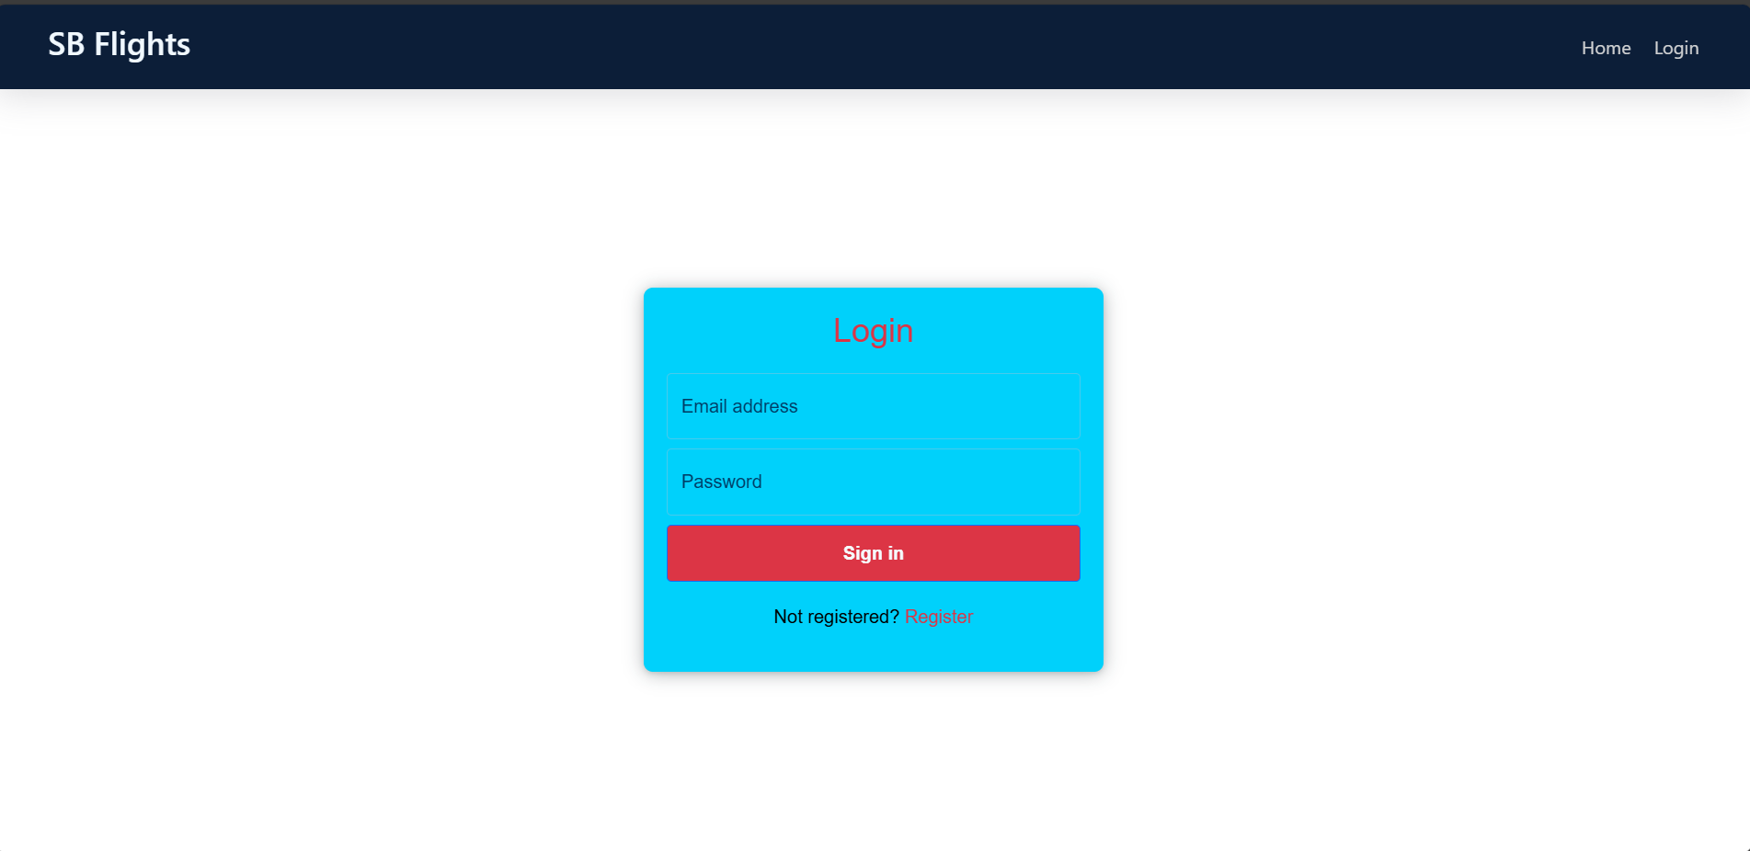

**Landing Page:**

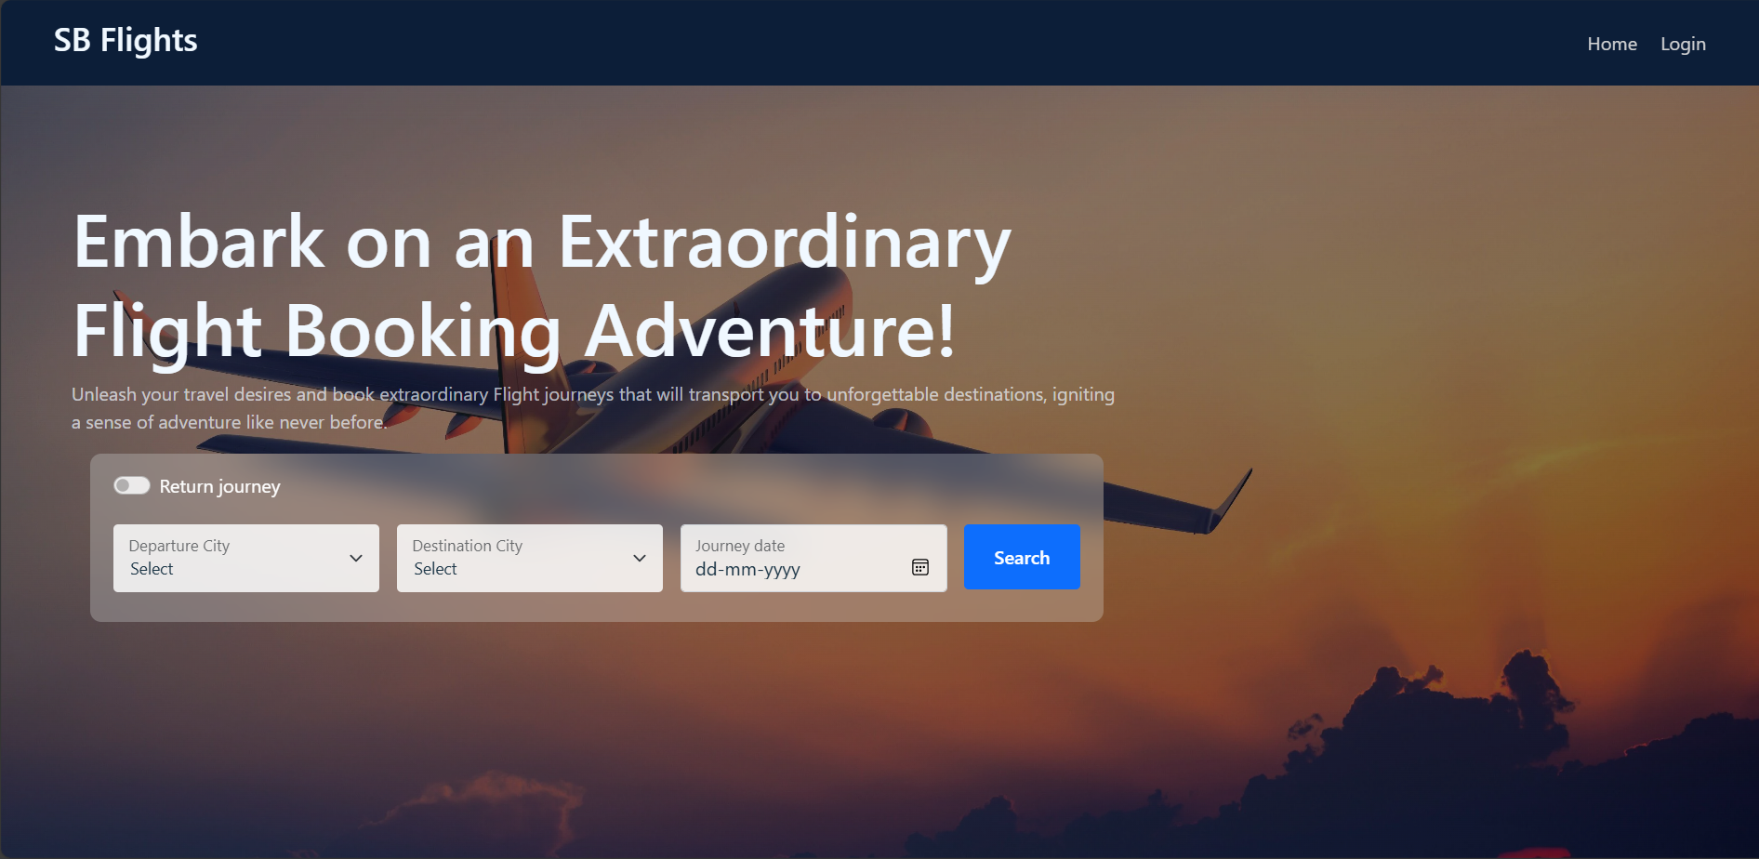

**7.1 Output Screenshots**

**User Bookings:**

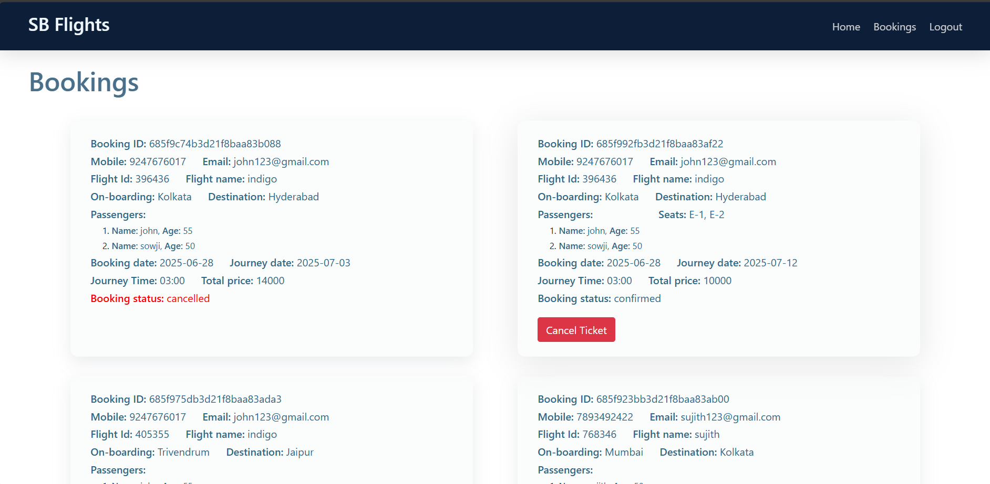



**All Users:**

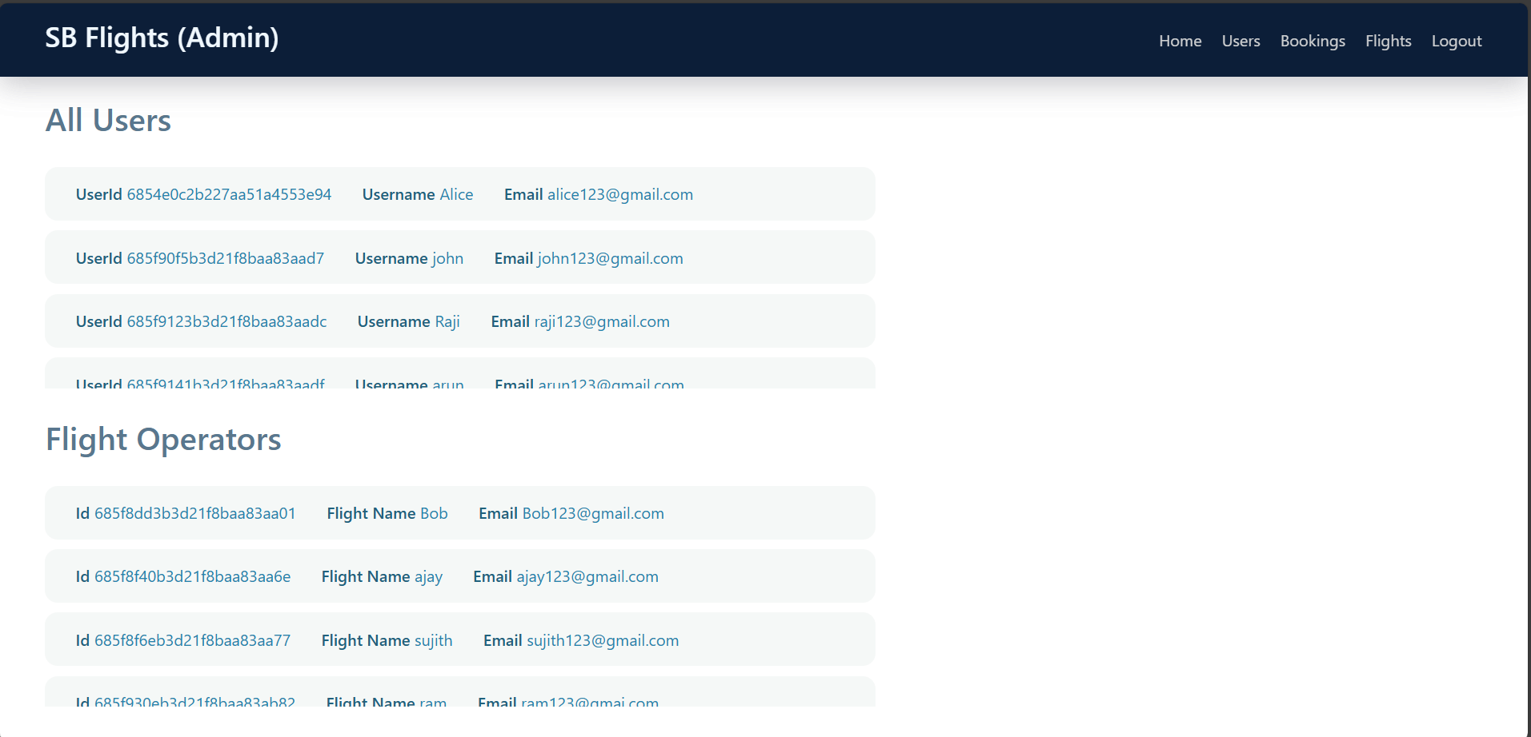

**Admin Dashboard:**

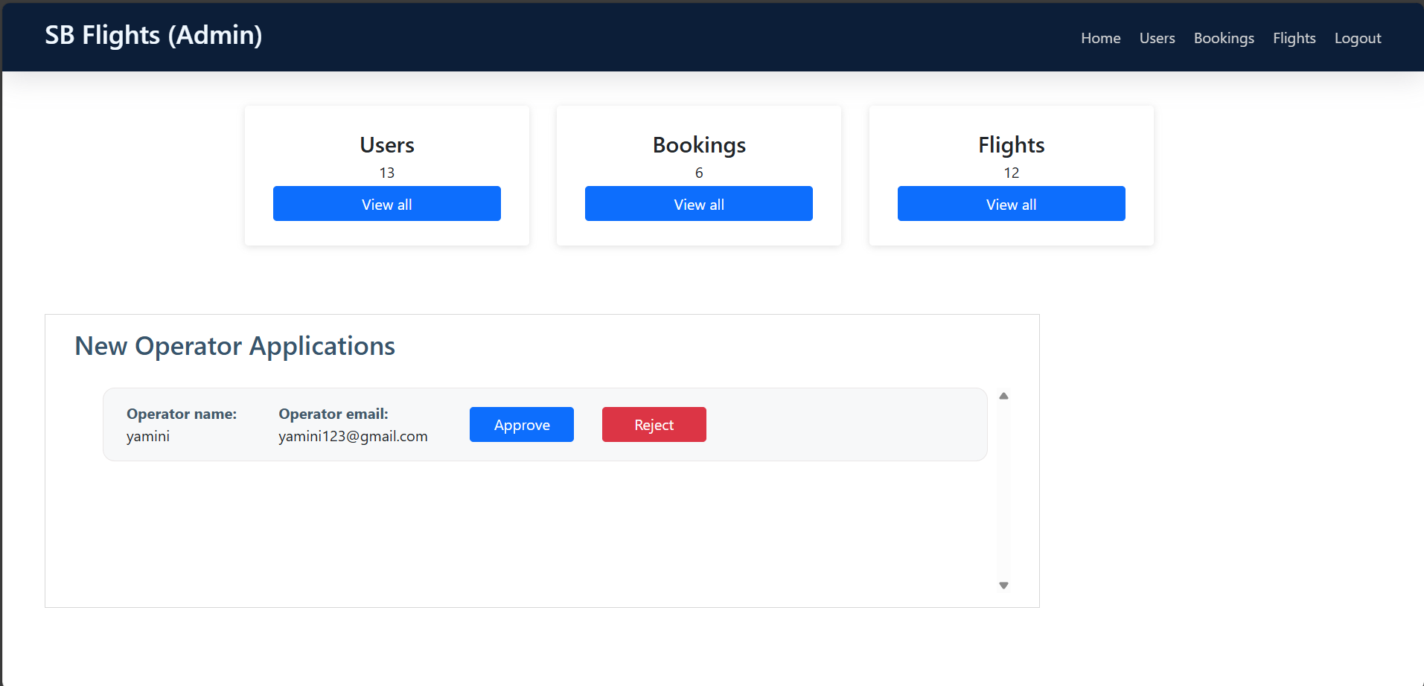

**Flight Operator:**

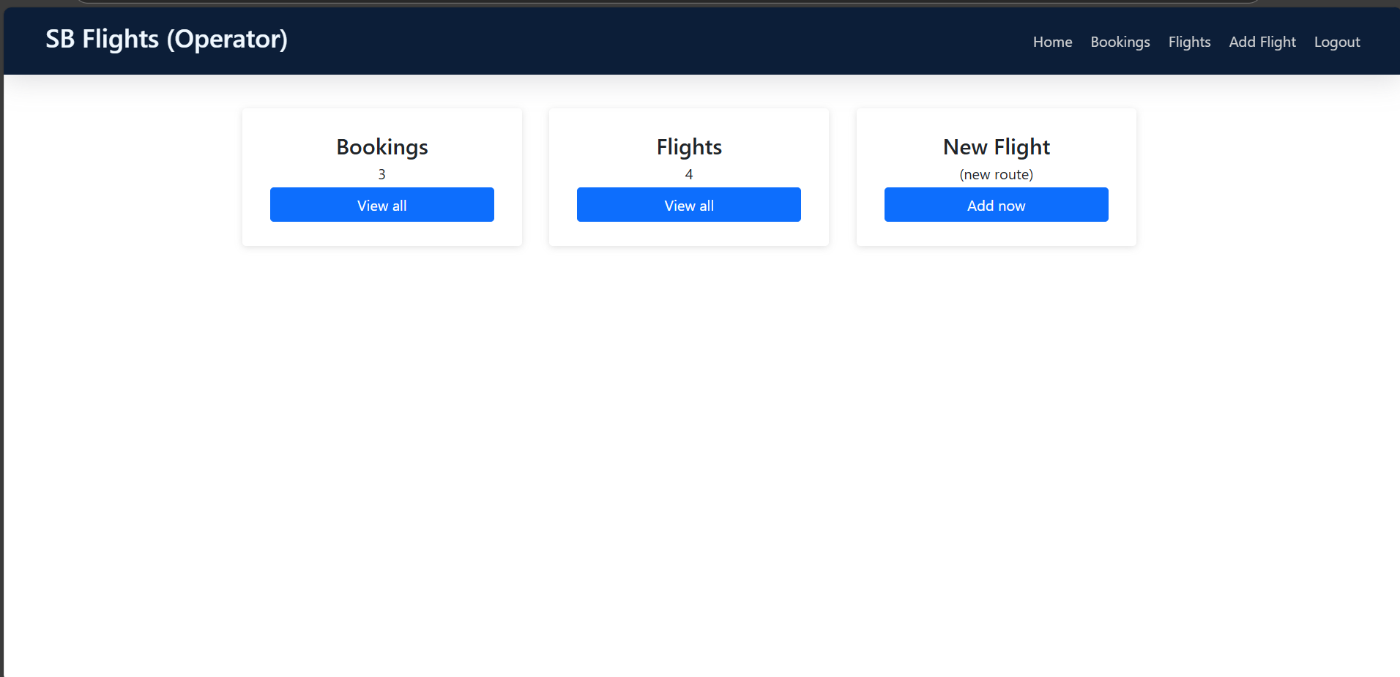

**New Flight:**

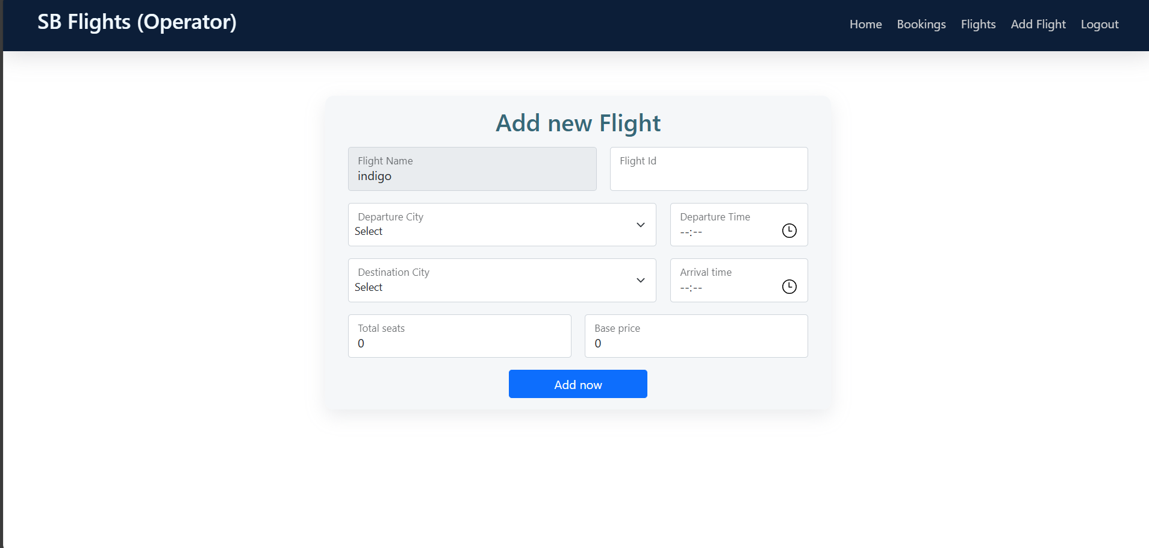

**All Bookings:**

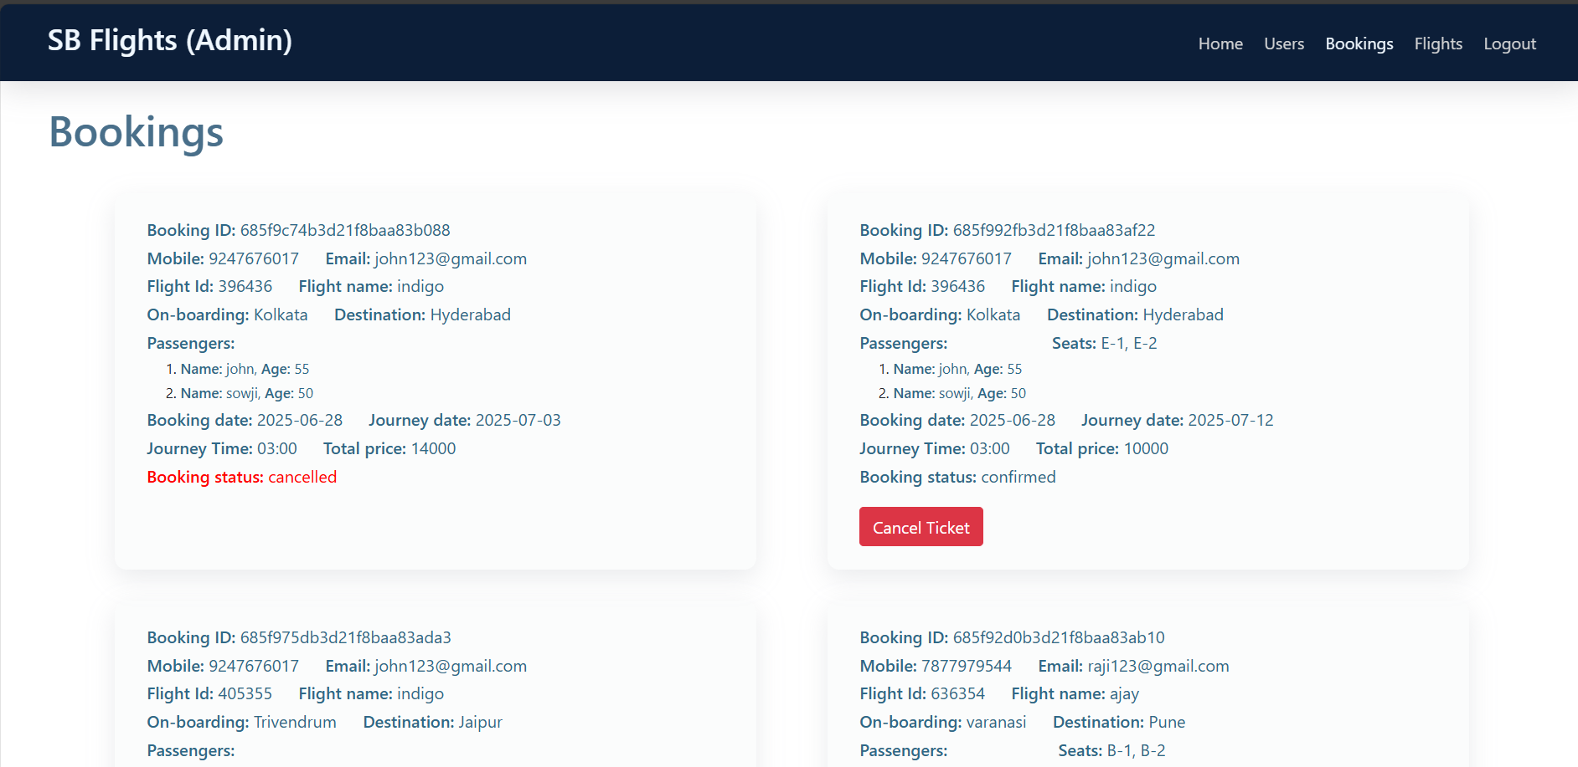

The **Flight Finder application** offers a smart, scalable solution to the fragmented and often frustrating process of searching, comparing, and booking flights. By providing a centralized, user-friendly platform with transparent pricing, secure transactions, and easy booking management, it significantly improves the travel planning experience for customers.

**9. CONCLUSION**

**Advantages**

* Provides a centralized platform to search, compare, and book flights from multiple airlines.
* Offers transparent pricing, reducing surprises from hidden fees.
* Saves customers time and effort by avoiding multiple websites.
* Includes secure, trackable online payments and refunds.
* Sends real-time notifications for bookings, cancellations, or schedule changes.
* Helps small airlines or agencies reach more customers.

**Disadvantages**

* Complex to integrate with multiple airline APIs and payment gateways.
* Requires maintaining large datasets and ensuring data accuracy in real time.
* High initial development cost and potential ongoing expenses for server infrastructure.
* Must strictly handle data privacy and compliance (GDPR, PCI-DSS for payments).
* Needs robust testing to handle peak loads and concurrency.

**8. ADVANTAGES & DISADVANTAGES**

**10. FUTURE SCOPE**

**User Experience Improvements**

* **Advanced Flight Filtering & Sorting:**  
  Allow users to filter flights by price, duration, layovers, airlines, time of day, and class.
* **Seat Selection Feature:**  
  Enable users to choose specific seats during booking, with real-time seat map updates.
* **Multi-Language & Multi-Currency Support:**  
  Add internationalization features to support global users with localized content and pricing.
* **Passenger Profile Management:**  
  Allow users to create accounts and save personal details, travel preferences, and frequent flyer info for faster booking.

**Flight Search & Real-Time Data**

* **Live Flight Pricing and Availability:**  
  Integrate with real-time airline APIs (e.g., Amadeus, Sabre, or Skyscanner) for accurate price and seat data.
* **Dynamic Pricing Engine:**  
  Implement an algorithm to adjust pricing based on demand, availability, or booking window.
* **Live Flight Tracking:**  
  Allow users to track live flight status (delays, gate changes, weather) via third-party API.

**Github Repository:-** https://github.com/L-Gayathri/Flight_Finder

**Project Demo Link:-**

https://drive.google.com/file/d/1WoPzAgsjbSTJLSOArWntXpMFqGc65pA2/view?usp=sharing

**11. APPENDIX**